

**MIDDLE EAST TECHNICAL UNIVERSITY**

**ELECTRICAL - ELECTRONICS ENGINEERING**

**EE400 SUMMER PRACTICE REPORT**

**Name:** Ali Tarık

**Surname:** Birsoy

**ID:** 2574796

----------------------------------------------------------

**SP Start Date:** 07.07.2025

**SP End Date:** 04.08.2025

**SP Company:** ASELSAN

**Sector:** REHIS

**Directorate:** Hardware Design

**Subdirectorate:** Power Electronics Design

---------------------------------------------------------

**Mentor:** Ecem Kandilli

**Mentor email:** ecemk@aselsan.com

**Mentor phone number:** +90 535 304 72 46

Contents:

1 – Introduction 3

2 – Description of the Company4

2.1 Company Name 4

2.2 Company Location 4

2.3 General Description of the Company 4

2.3.1 Organizational Structure of the Company 4

2.3.2 Activities 5

2.3.3 Location of Company and Number of Employees 6

2.4 Brief History of the Company 6

3 – The Project: Buck Converter in Theory 7

3.1 Background Knowledge on Buck Converters 7

3.1.1 What is a Buck Converter 7

3.1.2 Working Principle of a Buck Converter 8

3.1.3 Mathematical Equations 9

3.2 Component Research and Initial Design 10

3.3 Average Modelling and Bode Plot 11

3.4 Voltage Mode and Current Mode Control 12

3.5 Compensation – Type I, II, III 14

3.5.1 Type I Compensator 15

3.5.2 Type II Compensator 15

3.5.3 Type III Compensator 16

3.5.4 Comparison Table 17

3.5.5 The Compansator and Final Design 17

3.6 Loss Analysis 19

4 – The Project: Buck Converter in Practice 20

4.1 Physical Implementation 20

4.2 The Measurements 21

5 – Conclusions 26

6 – References 27

**1 Introduction**

I completed my second summer practice at ASELSAN company between 07.07.2025 and 04.08.2025. This company does research and development, production, and maintenance of various electronic warfare devices. During my summer internship, I worked in the Hardware Design directorate, Power Electronics Design subdirectorate under the mentorship of Ecem Kandilli.  
 During my summer practice, I continued the buck converter project I had started during my candidate engineering in ASELSAN. This project started with the research on components, then a research on the converter types, and continued with the implementation of a basic buck converter. During my internship, I further developed this project and added a feedback and compensation mechanism, manually generated sawtooth signals and reference voltage levels for the compensation network and the comparator, and various testing mechanisms for testing the load regulation, line regulation and the transient response. After carefully calculating the needed values, I simulated the converter on LTSpice. After successfully completing the design process with the simulation, I went on to realize this project on a perforated pertinax board with actual components.  
 Aside from the technical insight I gained during the making of this project, I have also learned how to work at a company, how to solve problems and how to collaborate with other interns and engineers for problem solving. This is an important aspect of the internship as soft skills are as important as technical skills.  
 In the following sections, I started the report by giving a brief introduction to ASELSAN. Then, I gave background information about my project and I explained the project I did in more detail and what I learned during this project. After that, I have summarized my impressions and experiences during the internship in the 'Conclusion' section. Finally, I listed the resources that have been used during this report.

**2 Description of the Company [1]**

**2.1 Company Name**

ASELSAN Elektronik Sanayi ve Ticaret A.Ş.

**2.2 Company Location**

**Macunköy Campus (General HQ) (HBT/UGES):**  
 **Adress:** Mehmet Akif Ersoy, 296. Cd No:16, 06200 Yenimahalle / ANKARA  
 **Phone:** +90 (312) 592 10 00

**Gölbaşı Campus (REHİS/SST):**  
 **Adress:** Konya Yolu 8.km, Oğulbey, 3051 Sokak No:3, 06830 Gölbaşı / ANKARA  
 **Phone:** +90 (312) 592 10 00

**Akyurt Campus (MEOS/AGS):**  
 **Adress:** Balıkhisar, Koca Seyit Onbaşı Sk. No:1, 06750 Akyurt / ANKARA  
 **Phone:** +90 (312) 592 10 00

**Temelli Campus:**  
 **Adress:** Başkent OSB Şadi Türk Bulvarı No:18/A, 06909 Malıköy - Sincan / ANKARA  
 **Phone:** +90 (312) 592 12 01

**Teknopark Istanbul:**  
 **Adress:** ASELSAN Teknopark, Sanayi Mahallesi, Teknopark Bulvarı No:1/10B, 34906 Pendik / İSTANBUL, Türkiye  
 **Phone:** +90 (312) 592 10 00

**METU Technopark:**  
 **Adress:** İhsan Doğramacı Blv. Üniversiteler Mah. No:31-1, ODTÜ TEKNOKENT, 06800 Çankaya / ANKARA  
 **Phone:** +90 (312) 987 35 00

**Hacettepe Technopark:**  
 **Adress:** Üniversiteler Mahallesi, 1596. Cadde, Hacettepe Teknokent 6. Ar-Ge C Blok No:6C/82, Beytepe Çankaya / ANKARA  
 **Phone:** +90 (312) 297 71 62

**2.3 General Description of Company**

**2.3.1 Organizational Structure [1]**

In *Figure 1*, you can see an organizational chart of the company:

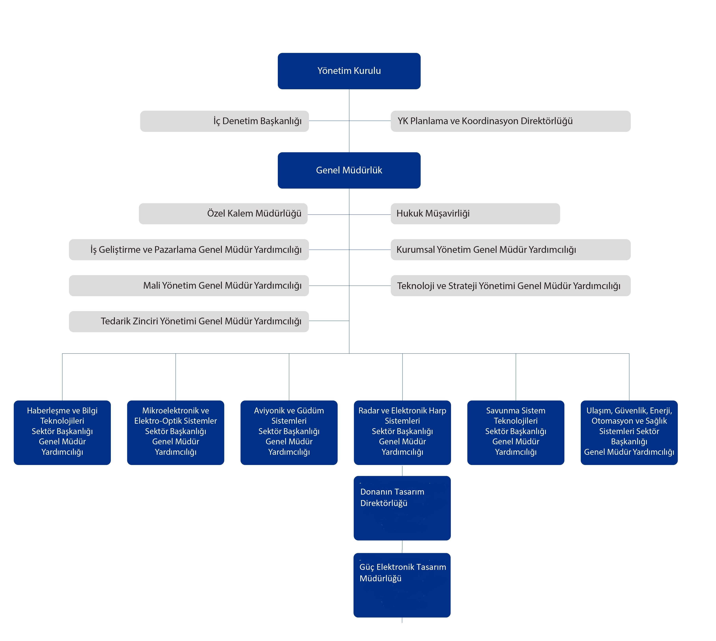

*Figure 1. Organizational Structure Chart of ASELSAN [1]*

**2.3.2 Activities**

ASELSAN aims and continues to offer advanced solutions and develop groundbreaking technologies in a wide range of fields. These include:

* Military Technologies: Air defense, radar, electronic warfare, electro-optics, avionics, guidance, land and weapon systems, underwater systems, communication, satellite and space systems, and command-control infrastructures.
* Civilian Technologies: Transportation, security, energy, and health technologies.

The company works on the design, development, production, testing, and integration of systems in these sectors, often with a focus on domestic innovation and high reliability. ASELSAN is the largest of its sector in Türkiye.

**2.3.3 Location of Company and Number of Employees**

ASELSAN is headquartered in Ankara, Türkiye. This location provides strategic advantages due to its proximity to government institutions, the Ministry of National Defense, and leading universities such as Middle East Technical University (METU) and Hacettepe University.

The company also operates several R&D and production facilities in:

* Istanbul – Teknopark İstanbul campus.
* Konya – Production and testing sites.
* Ankara Districts – Facilities in Macunköy, Gölbaşı, Akyurt, Temelli, METU Teknokent, and Hacettepe Teknokent.
* Other locations – Specialized branches and subsidiaries in Türkiye and abroad for cooperation, R&D, and exports.

According to public data, ASELSAN employs over 12,000 people. A large portion are engineers, with electrical and electronics engineers forming the majority due to the company’s focus on communication systems, radar, avionics, and electronic warfare. Other key engineering disciplines include mechanical, software, and aerospace engineering.

In addition to engineers, ASELSAN employs a significant number of technicians for testing, integration, and manufacturing operations, along with professionals in project management, finance, supply chain, and human resources.

**2.4 Brief History of Company**

ASELSAN was established in 1975 by the Turkish Armed Forces Foundation (TAFF), aiming to meet the Turkish Armed Forces' communication needs domestically and securely. Over the years, it has grown into a globally recognized defense electronics firm, exporting its advanced technologies worldwide.

Key milestones include: [1]

* 1975: Founded in response to embargoes affecting defense procurement.
* 1979: Began production operations at its Macunköy facilities in Ankara.
* 1990: Transitioned to a publicly traded company and reorganized its operations into three structured divisions.
* 1990s–2000s: Expanded its competencies to include radar, electronic warfare, command-control systems, electro-optics, and microelectronics.
* 2024: Climbed to 42nd place in the Defense News Top 100 defense companies list; launched over $400 million in new R&D and production investments; rose to 6th on Borsa İstanbul’s market capitalization ranking; and received top marks in corporate governance ratings.
* Present: ASELSAN continues to offer groundbreaking solutions in its fields.

**3 The Project: Buck Converter in Theory**

**3.1 Background knowledge**

**3.1.1 What is a Buck Converter**

A buck converter is a type of DC–DC converter used to step down and regulate an output voltage to a level lower than the input voltage. A typical buck converter consists of a switch which is commonly a MOSFET or an IGBT depending on the usage, an inductor, a capacitor, and a diode (or, in synchronous designs, a second switch replacing the diode). Because they operate by rapidly switching the current on and off, buck converters —along with other DC–DC topologies— are categorized as Switch Mode Power Supplies (SMPS).

The most common buck converter topology is illustrated in Figure 2.

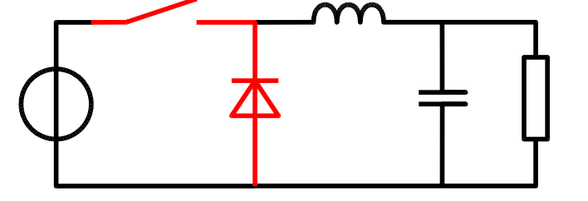

*Figure 2. A typical Buck Converter topology [2]*

**3.1.2 Working Principle of a Buck Converter**

A buck converters basic working principle is that by first using a higher input voltage, it quickly induces a current into an inductor. This is in accordance with Faraday’s and Lenz’s laws. Then, it disconnects the input and relies on the inductor’s stored energy to keep supplying current to output, often with the help of a diode that completes the circuit when the source is off. When the input is disconnected, the polarity is changed, again in accordance with Faraday’s and Lenz’s laws. The capacitor and inductor are needed for supplying energy and smoothing out the waveforms of the output current and voltage.

ON State: Upon closing the switch, current begins to flow and energize the circuit. The inductor responds to this increasing current by generating a back electromotive force (EMF) that directly opposes the source voltage. The magnitude of this induced voltage is proportional to the rate of change of the current, as described by the formula $V_{L}=L.\frac{di}{dt}$ This opposing voltage initially reduces the net voltage available to the load. As the current approaches a steady state, its rate of change slows, causing the back EMF to decay. Consequently, the voltage across the load increases. During this entire phase, the inductor stores energy in its growing magnetic field.

OFF State: When the switch is opened, the circuit is disconnected from the input voltage source. The current flowing through the inductor begins to decrease, causing its magnetic field to collapse. To counteract this change and maintain current flow, the collapsing field induces a forward voltage, effectively turning the inductor into a temporary current source. The energy that was previously stored in the magnetic field is now released, supplying power and sustaining the current through the load. The diode (or the second switch in synchronous converters) is now in conduction to complete the current path. This current, flowing while the input voltage source is disconnected, when appended to the current flowing during on-state, totals to current greater than the average input current (being zero during off-state).

A graph showing the inductor current, output voltage, inductor voltage drop and the switch stage can be seen in Figure 3.

,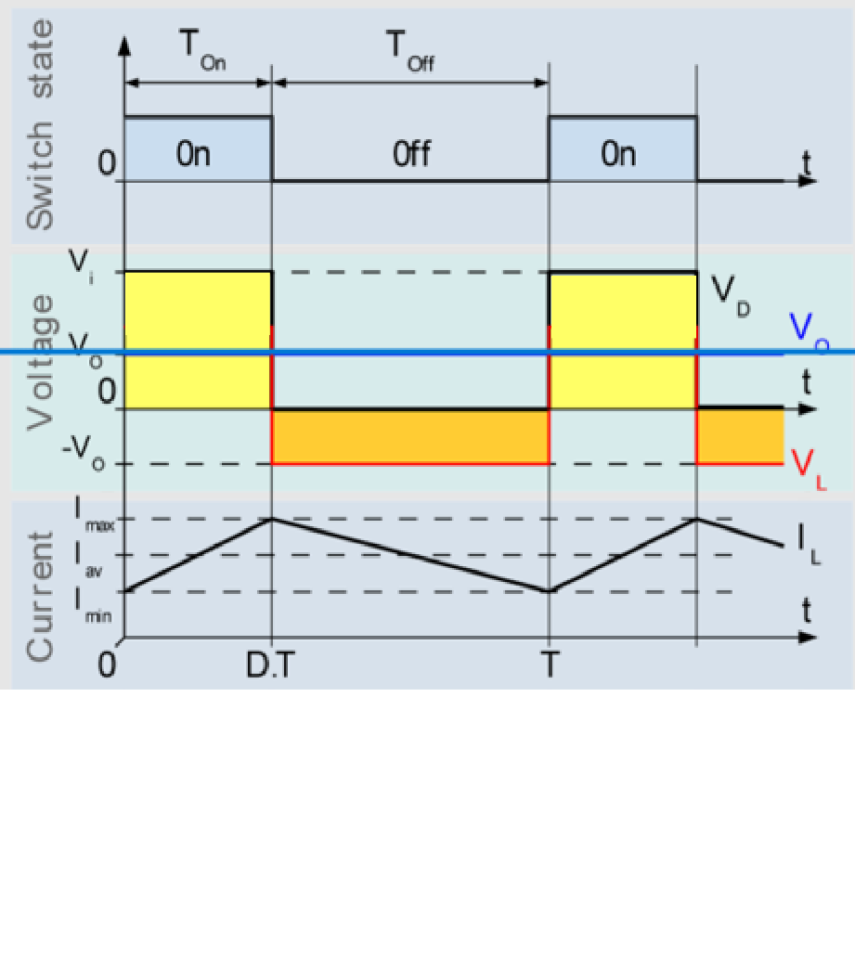

*Figure 3. Evolution of $V_{o},V_{d},V_{l}∧I_{l}$ with time [2]*

**3.1.3 Mathematical Equations**

In a buck converter, the output voltage $V_{out}$ is less than or equal to the input voltage $V_{in}$. While this is always true, the relationship between the input and output voltages change according to the current mode of the buck converter. In a DCM (discontinuous current mode) buck converter, the inductor current drops to 0 for a certain amount of time in each period, making the calculations more complicated. However, in a CCM (continuous current mode) which is what has been used in the following project, the inductor current never drops to zero. For a CCM buck converter, the relationship between output and input voltage is given by:

$$\begin{matrix}V_{\text{out}}=D×V_{\text{in}} & (1)\end{matrix}$$

where D is the duty cycle of the switching element, defined as the ratio of the switch ON time $t_{on}$ ​ to the total switching period T:

$$D=\frac{t_{\text{on}}}{T}$$

Since the switch is driven by a PWM (Pulse Width Modulation) signal, the duty cycle of the PWM controls the average output voltage.

As seen in Figure 3, the current passing through the inductor and the output voltage have ripples. The inductor current ripple can be calculated as

$$\begin{matrix}ΔI_{L}=\frac{V_{\text{in}}-V_{\text{out}}}{L}×DT=\frac{(V_{\text{in}}-V_{\text{out}})×D}{Lf_{s}} & \text{(2}\text{)}\end{matrix}$$

or equivalently (by inserting equation (1))

$$ΔI_{L}=\frac{V_{\text{in}}(1-D)D}{Lf_{s}}$$

where:

* L is the inductance,
* $T=\frac{1}{f_{s}}$ ​ is the switching period,
* $f_{s}$ is the switching frequency.

We can see that the inductance of the inductor and the switching frequency are key factors in the current ripple.

The output voltage ripple $ΔV_{out}$ ​ is determined by the capacitor C and the inductor current ripple, assuming the capacitor's Equivalent Series Resistance (ESR) is negligible:

$$\begin{matrix}ΔV_{\text{out}}=\frac{ΔI_{L}}{8f_{s}C} & \text{(3}\text{)}\end{matrix}$$

If the capacitor ESR is significant, the ripple due to ESR is:

$$ΔV_{\text{ESR}}=ΔI_{L}×R_{\text{ESR}}$$

The total output voltage ripple is approximately the sum of these two components:

$$ΔV_{\text{out, total}}≈ΔV_{\text{out}}+ΔV_{\text{ESR}}$$

**3.2 Component Research and Initial Design**

Our mentor asked us to design a buck converter that works with a 10 kHz switching speed, 24-32 V input and 12 V output, 6W output power, 3% output voltage ripple and 30% inductor current ripple. The buck converter was supposed to work in continuous current mode. These criteria are for the full load case. According to these criteria, my friend (Hüseyin Çetin, Gazi EEE, 3rd year) and I did research on the components we could use. We did research on the capacitor types we could use, and chose our MOSFETs, diodes and other components. We learned about the different types of capacitors based on their materials, critical values like ESR and leakage current, etc. For the inductors, we learned about core types, which type to choose, and other critical points like DCR. Then, using the formulas above and putting in the given criteria, we chose the appropriate sizes and materials for the inductor and the capacitors. We chose 19.7uF for the input and output capacitors and 4.7mH for the inductor. We chose to use ceramic capacitors for the entire application for lower losses and less effects on stability of the control loop. For the switches, a Schottky diode is chosen for fast recovery as the reverse recovery process of a diode causes losses, and a high-side PMOS is chosen for ease of operation. The initial design is given in Figure 4.

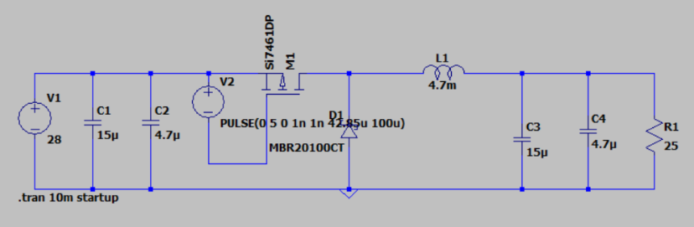

*Figure 4. Initial Design*

**3.3 Average Modelling and Bode Plot**

Referring to chapter 14 in Fundamentals of Power Electronics by Erickson [3], we see that we can linearize and approximate the switching behavior of SMPS circuits using the fact that the formula $i_{C}=C.\frac{dV_{c}}{dt}$ and $v_{L}=L\frac{di_{L}}{dt}$ hold out the same when averaged, that is,

$⟨v_{L}⟩_{T_{s}}=L\frac{di_{L}}{dt}⟨i_{C}⟩_{T_{s}}=C\frac{dv_{C}}{dt}$ (4)

After we reach this point, we can swap our switches with behavioral sources that mimic the same current and voltage as switches. Furthermore, when we use state-space representation to get the small signal model, we see that the transfer function of the average model is identical to the transfer function of the original model. This allows us to use the average model in our simulations. The reason we use average modelling in our simulations is to gain speed without losing accuracy, and to get a proper Bode plot to work on. We need measurements from the Bode plot such as phase margin, gain margin and the crossover frequency fco. In Figure 5, the difference between the output voltages of normal and average model can be seen. In Figure 6, the Bode plot acquired by using the average model can be seen. All the design and measurement processes are done on LTspice.

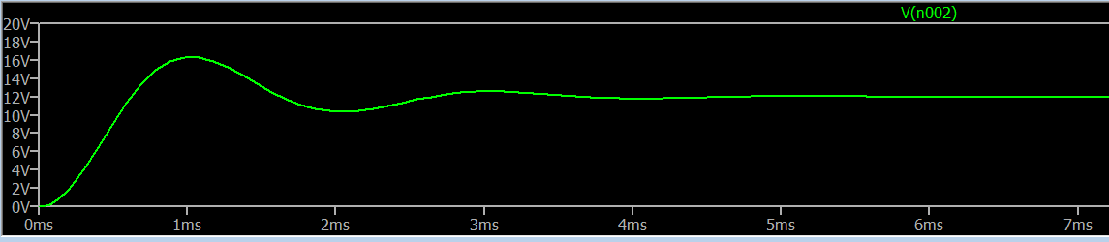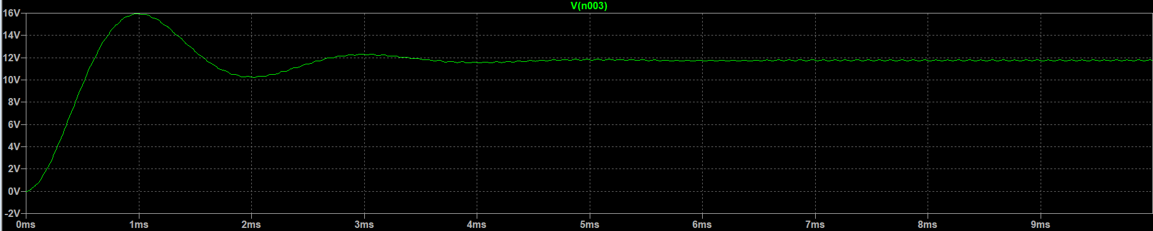

*Figure 5. Startup transient of average model (top) vs normal model (bottom)*

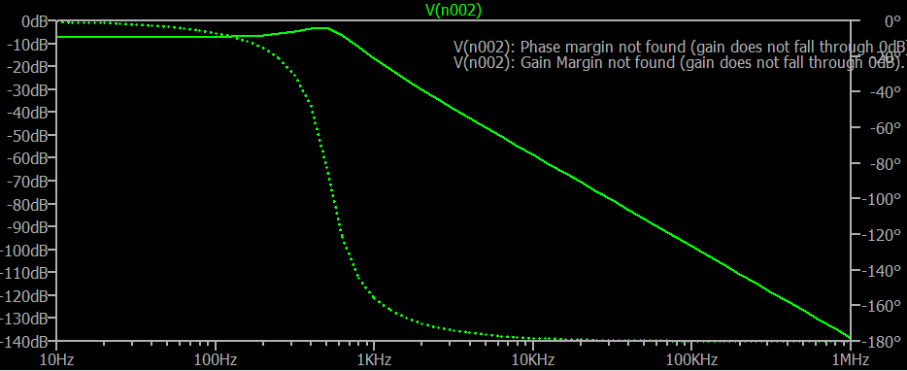

*Figure 6. Bode plot of the average model*

**3.4 Voltage Mode and Current Mode Control**

After the initial design was completed successfully, the next step was to implement a feedback mechanism such that the circuit gives the same output voltage even when the input voltage or the load changes. To do this, there are two different techniques that are used on SMPS converters, namely the Voltage Mode Control (VMC) and the Current Mode Control (CMC). In VMC, the output voltage is directly sensed using a voltage divider at the output, and the error is compared with a reference voltage in an error amplifier. After the error amplifier amplifies the error, the amplified error is compared to a sawtooth/triangle waveform in a comparator, which then produces the PWM as an output. The output then goes into the gate driver (low-side NMOS), which drives the main switch (high-side PMOS). The process is similar in a CMC, but the main difference is that the error is also sensed from the inductor current and then compared with the amplified output voltage error. This allows for tighter control over the circuit, which leads to a better transient response. In Figure 7, the difference between VMC and CMC can be seen. In Table 1 there is a comparison of the two methods.

One thing to note is that while using CMC is generally more beneficial, a problem called subharmonic oscillation can occur. The problem occurs when the duty cycle $D>0.5$. In this case, the inductor current does not return to its initial value before being sensed again, especially under perturbation. As a result, small errors in current sensing accumulate over successive cycles, eventually leading to subharmonic oscillations and instability in the feedback loop. To solve this problem, we use a method called slope compensation.

Let m1 be inductor current during up slope (on time) and m2 be inductor current during down slope (off time). Then, $m_{1}=\frac{V_{\text{in}}-V_{o}}{L}$ and $m_{2}=\frac{-V_{o}}{L}$.

If $D>\frac{m_{2}}{m_{1}+m_{2}}$ in our converter, the subharmonic oscillation occurs. To prevent this, an artificial slope ma is added. Using the formulae above, we see that $m_{a}>\frac{m_{2}-m_{1}}{2}$ for a stable system. If we replace the values for our buck converter, we see that

$m_{a}≥\frac{V_{o}}{2L}$ (5)

for stability.

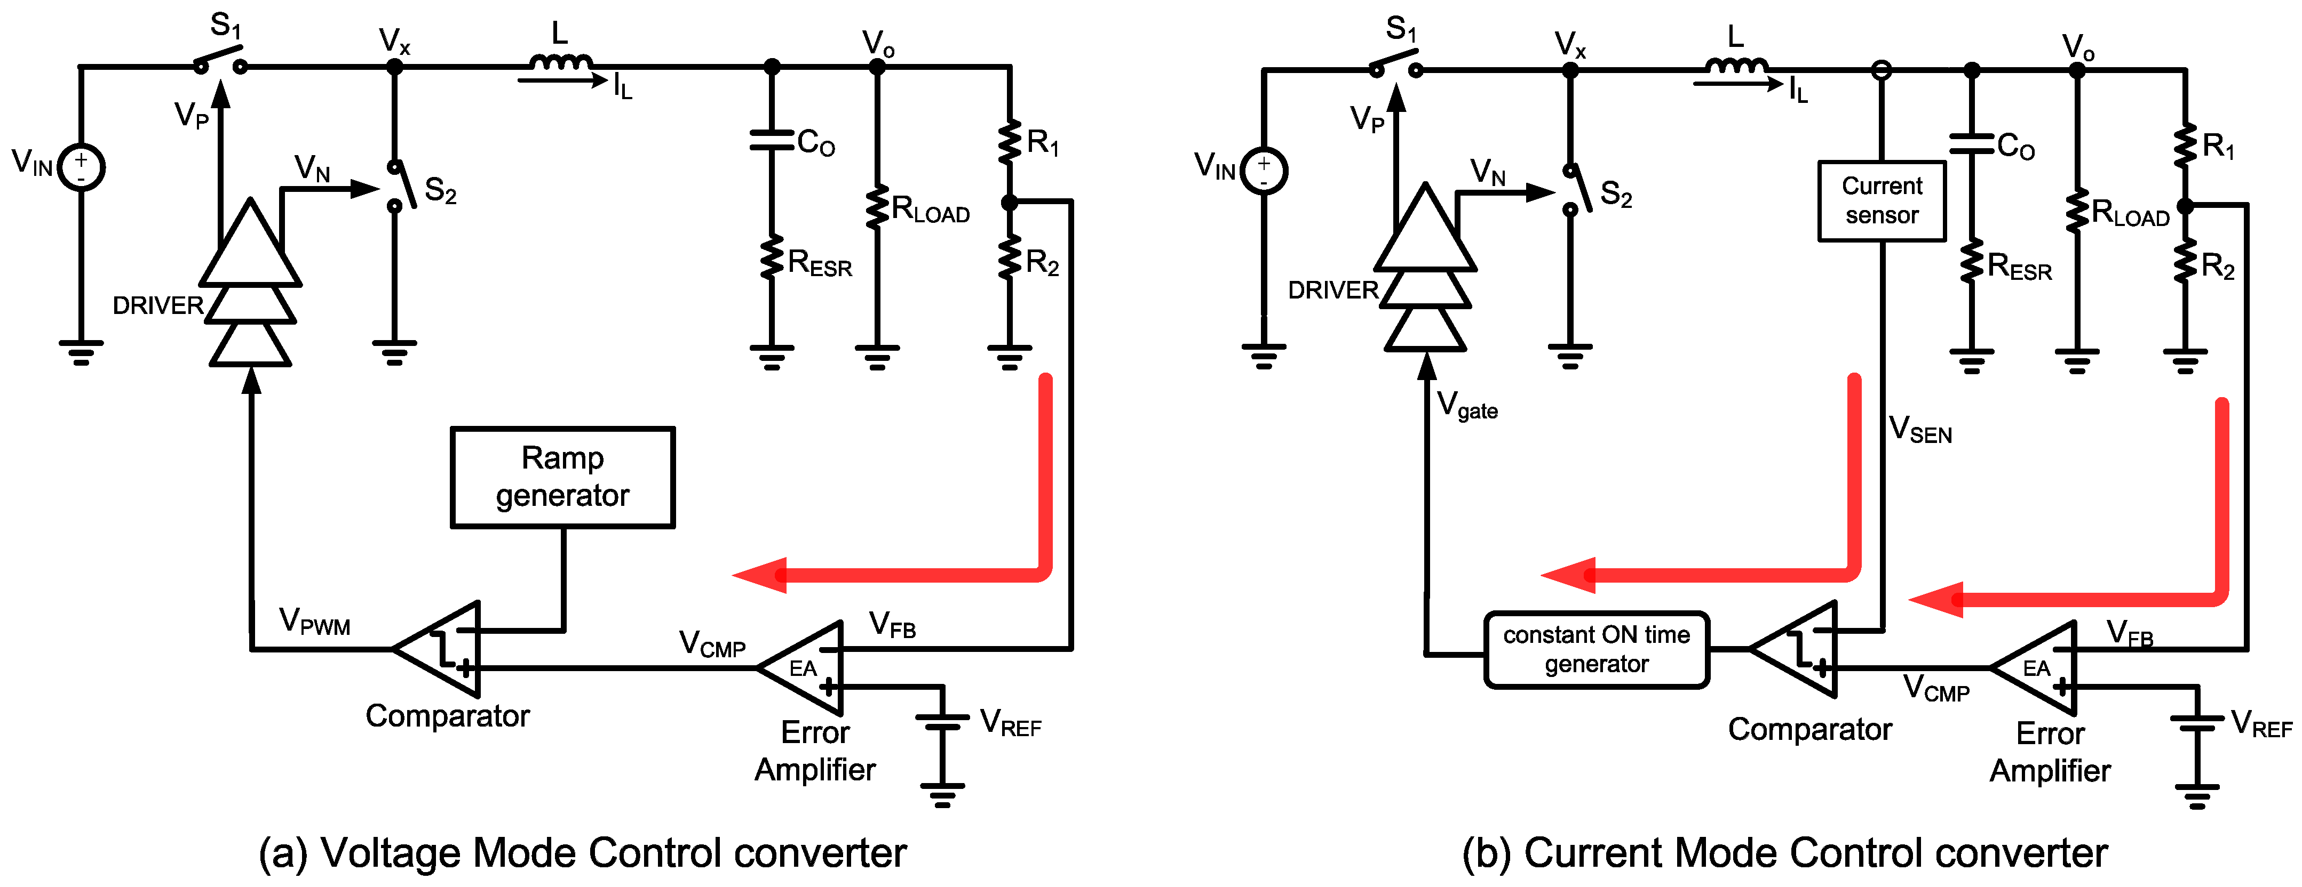

*Figure 7. VMC and CMC [4]*

*Table 1. VMC vs CMC*

|  |  |  |
| --- | --- | --- |
| Feature | Voltage Mode Control (VMC) | Current Mode Control (CMC) |
| Primary Control Variable | Output voltage error signal is applied directly to PWM | Inductor current is controlled in the inner loop, output voltage in the outer loop |
| Dynamic Response | Slower, less sensitive to load changes | Faster, better response to load changes |
| Transfer Function | $$G=\frac{V_{}}{1+\frac{sL}{R}+s^{2}LC}$$ | $$G=\frac{R_{load}}{1+sR_{load}C}$$ |
| Compensation Requirement | Usually requires Type 3 compensator | Type 2 compensator is usually sufficient |
| Stability | Needs careful design to ensure good phase margin | Easier to stabilize, fewer low phase margin problems |
| Noise Sensitivity | More affected by input voltage ripple | Noise from current sensor can affect performance / subharmonic oscillation |
| Complexity | Simpler, no current measurement required | More complex, needs resistor/sensor for current measurement |
| Application Area | Simple applications, low-cost SMPS | High-performance SMPS, fast transient systems, Boost and Buck-Boost (RHPZ) |

In Table 1, we can see that the orders of the transfer functions are different. The reduced order of the transfer function of CMC means there is much less phase lag, which is why the system can respond faster compared to VMC.

**3.5 Compensation – Type I, II, III [5]**

As can be seen from Figure 6, the gain margin (GM) and phase margin (PM) of our circuit is not desirable. In order to have a stable circuit, we need to have a GM of above 6 dB and a PM of above 45 degrees. To achieve these values, we need to add a compensation network where our error amplifier is. It is important to choose the correct type of compensation network in order to have the necessary amount of gain and phase boost. There are 3 types of compensators we can use, and we will see each of them and choose the appropriate one for our application.

**3.5.1 Type I Compensator**

Type I compensator is the simplest form of a compensation network, which is characterized by a single pole. It has a single capacitor in addition to the error amplifier, which can be seen in Figure 8. The approximated frequency response of a Type I compensator can also be seen in Figure 8. Type I compensators are mostly not sufficient for SMPS converters and mostly used in low power regulators.

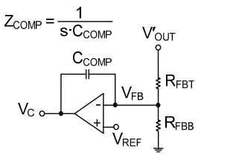 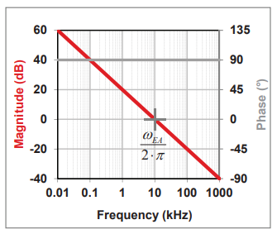

*Figure 8. Type I compensator and frequency response [5]*

**3.5.2 Type II Compensator**

A Type II compensator has an RC branch in parallel with the capacitor from the Type I compensator which means that it has one pole and one zero. The added zero allows for the designer to add a flat region around the crossover frequency, adding a phase boost of up to 90 degrees in theory and 45 degrees in practice. A Type II compensator is suited for some simple topologies like a CMC buck converter, while the limited phase boost is usually not sufficient for cases like VMC buck or boost and buck-boost topologies, of which the last two have Right Half Plane Zero’s which cause a significant phase lag. The topology and the approximated frequency response of a Type II compensator can be seen in Figure 9, along with the transfer function.

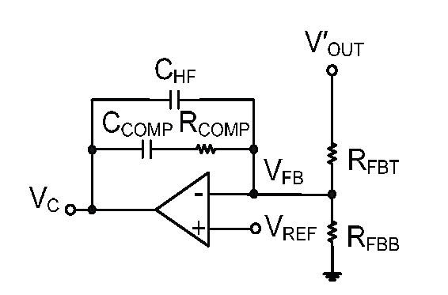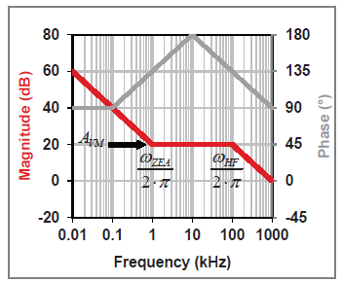

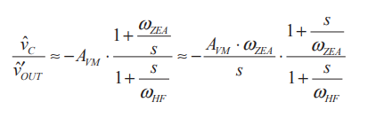

*Figure 9. Type II compensator, frequency response and transfer function [5]*

**3.5.3 Type III Compensator**

A Type III compensator has an extra C (or RC) branch in addition to the topology in Type II. This means that the designer has another pole zero pair in their hands, allowing them to have much better control over the frequency response. With a Type III compensator, 180 degrees in theory and 60-90 degrees of practical phase boost can be achieved. This additional phase boost is extremely helpful and often necessary when using a more advanced topology like a VMC buck or a boost/buck-boost converter which has more phase lag than a CMC buck. Since we have designed a VMC buck, Type III compensator is utilized in our project as well. The topology and frequency response, as well as the transfer function of a Type III compensator can be seen in Figure 10. 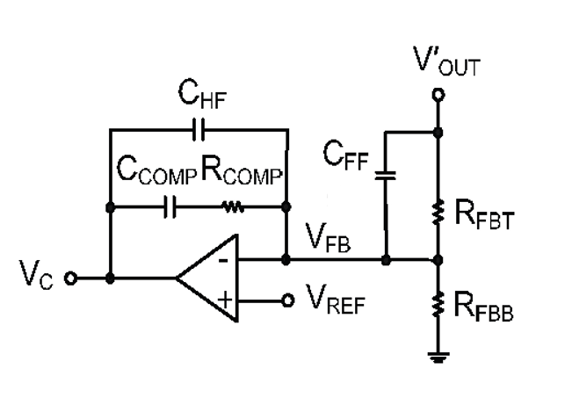 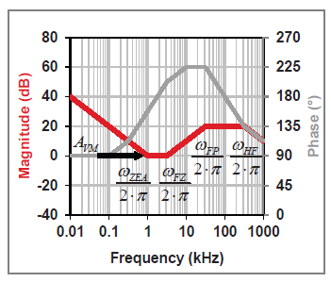

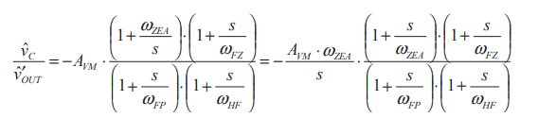

*Figure 10. Type III compensator, frequency response and transfer function [5]*

**3.5.4 Comparison Table**

*Table 2. Type I, Type II, Type III Compensators*

|  |  |  |  |
| --- | --- | --- | --- |
| Feature | Type 1 Compensator | Type 2 Compensator | Type 3 Compensator |
| Main Purpose | Contains 1 pole | Contains 1 pole and 1 zero | Contains 2 zeros and 2 poles |
| Frequency Response | Provides DC gain only, no mid-frequency phase boost | Provides phase boost at mid frequencies | Provides higher phase boost |
| Phase Margin | Does not improve phase margin | Increases phase margin by up to ~45° | Provides 60° or more phase margin |
| Complexity | Very simple design | Simpler design | More complex, more components |
| Application Area | Very low bandwidth applications, constant load, power factor correction | Simple and moderately complex DC-DC converters (CMC) | Applications requiring higher bandwidth and phase margin (VMC) |
| Advantages | Easiest design and tuning | Easier to design and tune | Wider phase margin and improved stability |
| Disadvantages | Poor high-frequency performance, limited stability improvement | Limited phase margin, lower high-frequency performance | Harder to design and tune, more complex circuit |

**3.5.5 The Compansator and Final Design**

As mentioned above, since we are using VMC, we need to have a high phase boost. Therefore, Type III compensator is chosen for our project. In order to calculate the necessary resistor and capacitor values, we use the formulas given in the book of Hart[6], chapter x. The formulas are given in Figure 11.

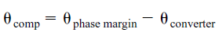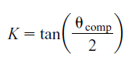

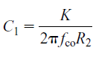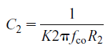 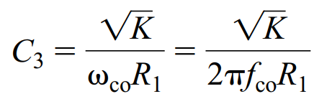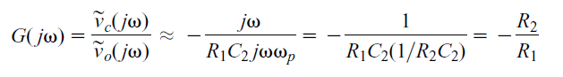

*Figure 11. Formulas used in calculating compensator values [6]*

First, we have to calculate how much phase boost we need to add. By checking the bode plot obtained from the average model and setting a goal of 45 degrees phase margin, we find Θcomp as 110 degrees, we see that our K value is 1.42. Then, we choose an appropriate fco which is usually chosen as one fifth or one tenth of the switching frequency. We chose 1.3 kHz for convenience. Then, putting the numbers in the formulae seen in Figure 11, we complete our design. The completed design is given in Figure 12, where the calculated values of the compensator can be seen.

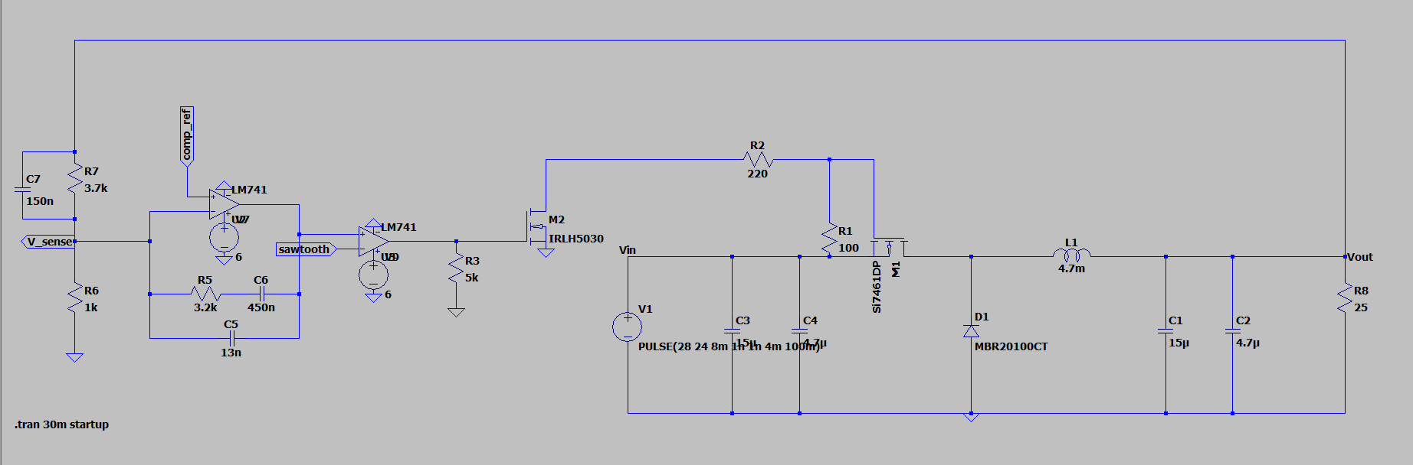

*Figure 12. Complete design of buck converter with Type 3 feedback.*

The capacitor C3 is the feedforward capacitor, which allows a short path for high frequency error signals, therefore making the response better. It is a crucial part of the compensator, upgrading the Type II compensator to a Type III compensator.

This design needs two external signals, one of them being the reference signal going into the error amplifier and is labeled “comp_ref”, and the other signal is the sawtooth signal which is needed in the comparator in order to generate a PWM. They are also generated by using custom circuits, since the project requires us to use no more than two DC supplies. The reference signal comp_ref is generated using a TL431 IC made by Texas Instruments. The sawtooth signal is simply generated using an op-amp and the charge-discharge path of a capacitor. Generation of both signals can be seen in Figure 13.

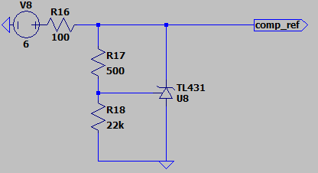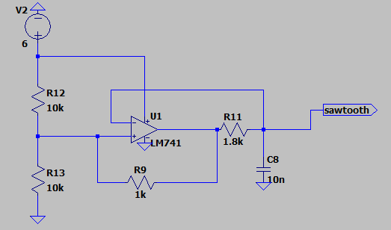

*Figure 13. DC reference (left) and sawtooth signal (right)*

When the simulation is run, we see that the DC output voltage is 12V as intended. We can also see the inputs of the comparator (the sawtooth signal and the error amplifier output) and the output of the comparator, which is the gate driver PWM. The simulation results mentioned are given in Figure 14.

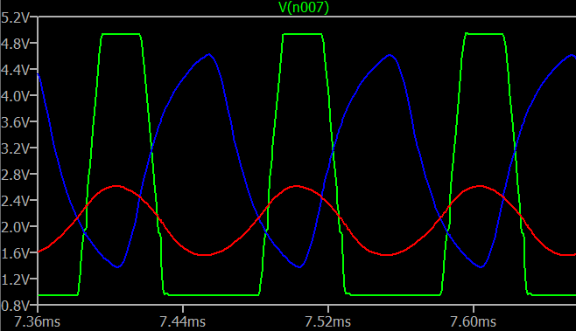 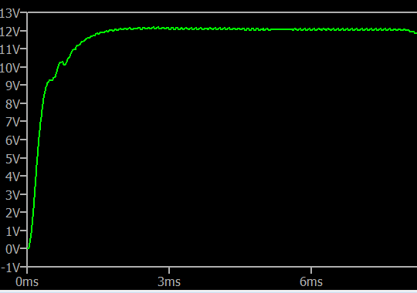

*Figure 14. Comparator inputs and output (left) and DC output (right)*

**3.6 Loss Analysis**

Before delving into the real-life application and the measurements of the circuit, we should also calculate our losses. For the calculation of losses, the formulae given by Rohm, Inc. [5] is used. For better visualization, the losses are made into Table 3. When we calculate the output power (5.7W) and the losses (400 mW), we can calculate the efficiency of the converter as %93. Feedback loop losses are not included in the calculations as they are negligible compared to other losses.

*Table 3. Loss Analysis*

|  |  |  |  |
| --- | --- | --- | --- |
| Component | Loss Type | Formula | Value |
| MOSFET | Conduction Loss | $$P_{on-M}={\left(I_{out}*D\right)}^{2}*R_{on}$$ | 0.48 mW |
| Diode | Conduction Loss | $$P_{on-D}=I_{out}*(1-D)*V_{F}$$ | 132.6 mW |
| Inductor | Conduction Loss | $$P_{L}=I_{out}^{2}*DCR$$ | 230 mW |
| MOSFET | Switching Loss  Gate Charge Loss | $$P_{SW}=\frac{1}{2}*V_{}*I_{out}*\left(t_{r}+t_{f}\right)*f_{SW}$$ 𝑃_𝐺 = (𝑄𝑔−𝐻 + 𝑄𝑔−𝐿) × 𝑉𝑔𝑠 × 𝑓_sw | 25.7 mW (main switch) + 4mW(driver) |
| Diode | Reverse Recovery Loss | $$P_{D}=\frac{1}{2}*V_{}*I_{RR}*t_{rr}*f_{SW}$$ | Negligible (Schottky) |
| Capacitor | Conduction Loss | $$P_{C}=I_{ripple_{rms}}^{2}*ESR$$ | 1.2 mW |

**4 The Project: Buck Converter in Practice**

**4.1 Physical Implementation**

We first started realizing the project by generating the necessary signals, that is, the comp_ref and the sawtooth signal. As mentioned in chapter 3.5.5, we generated the reference signal using a TL431, and the sawtooth signal with a single op-amp. They can be seen in Figure 15. The project is realized on a perforated pertinax board by hand.

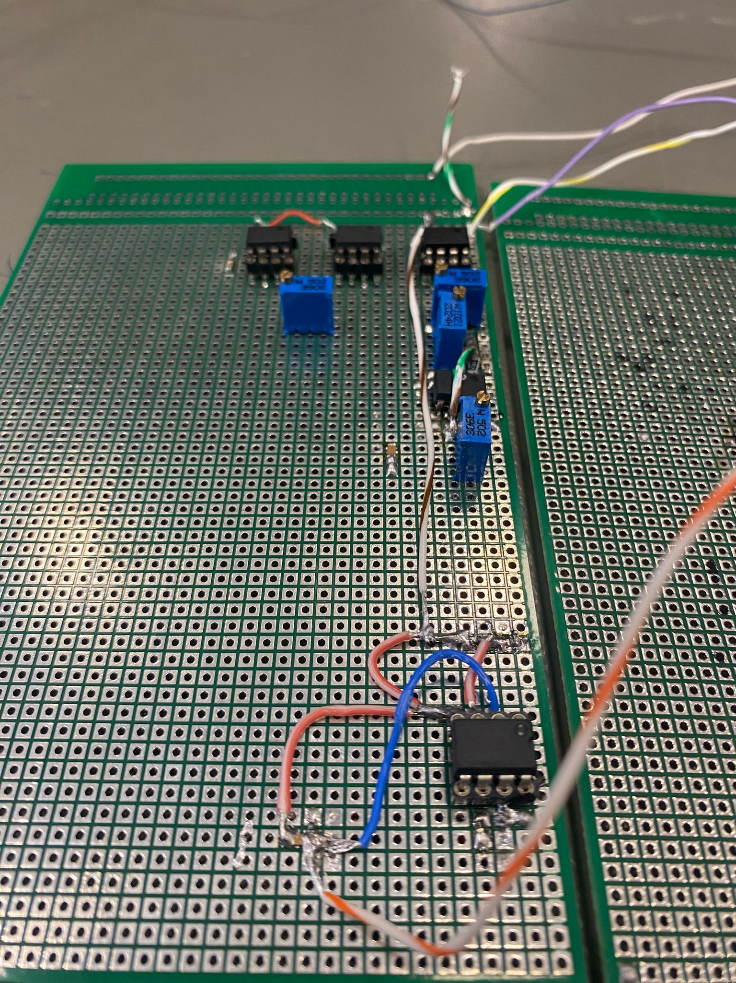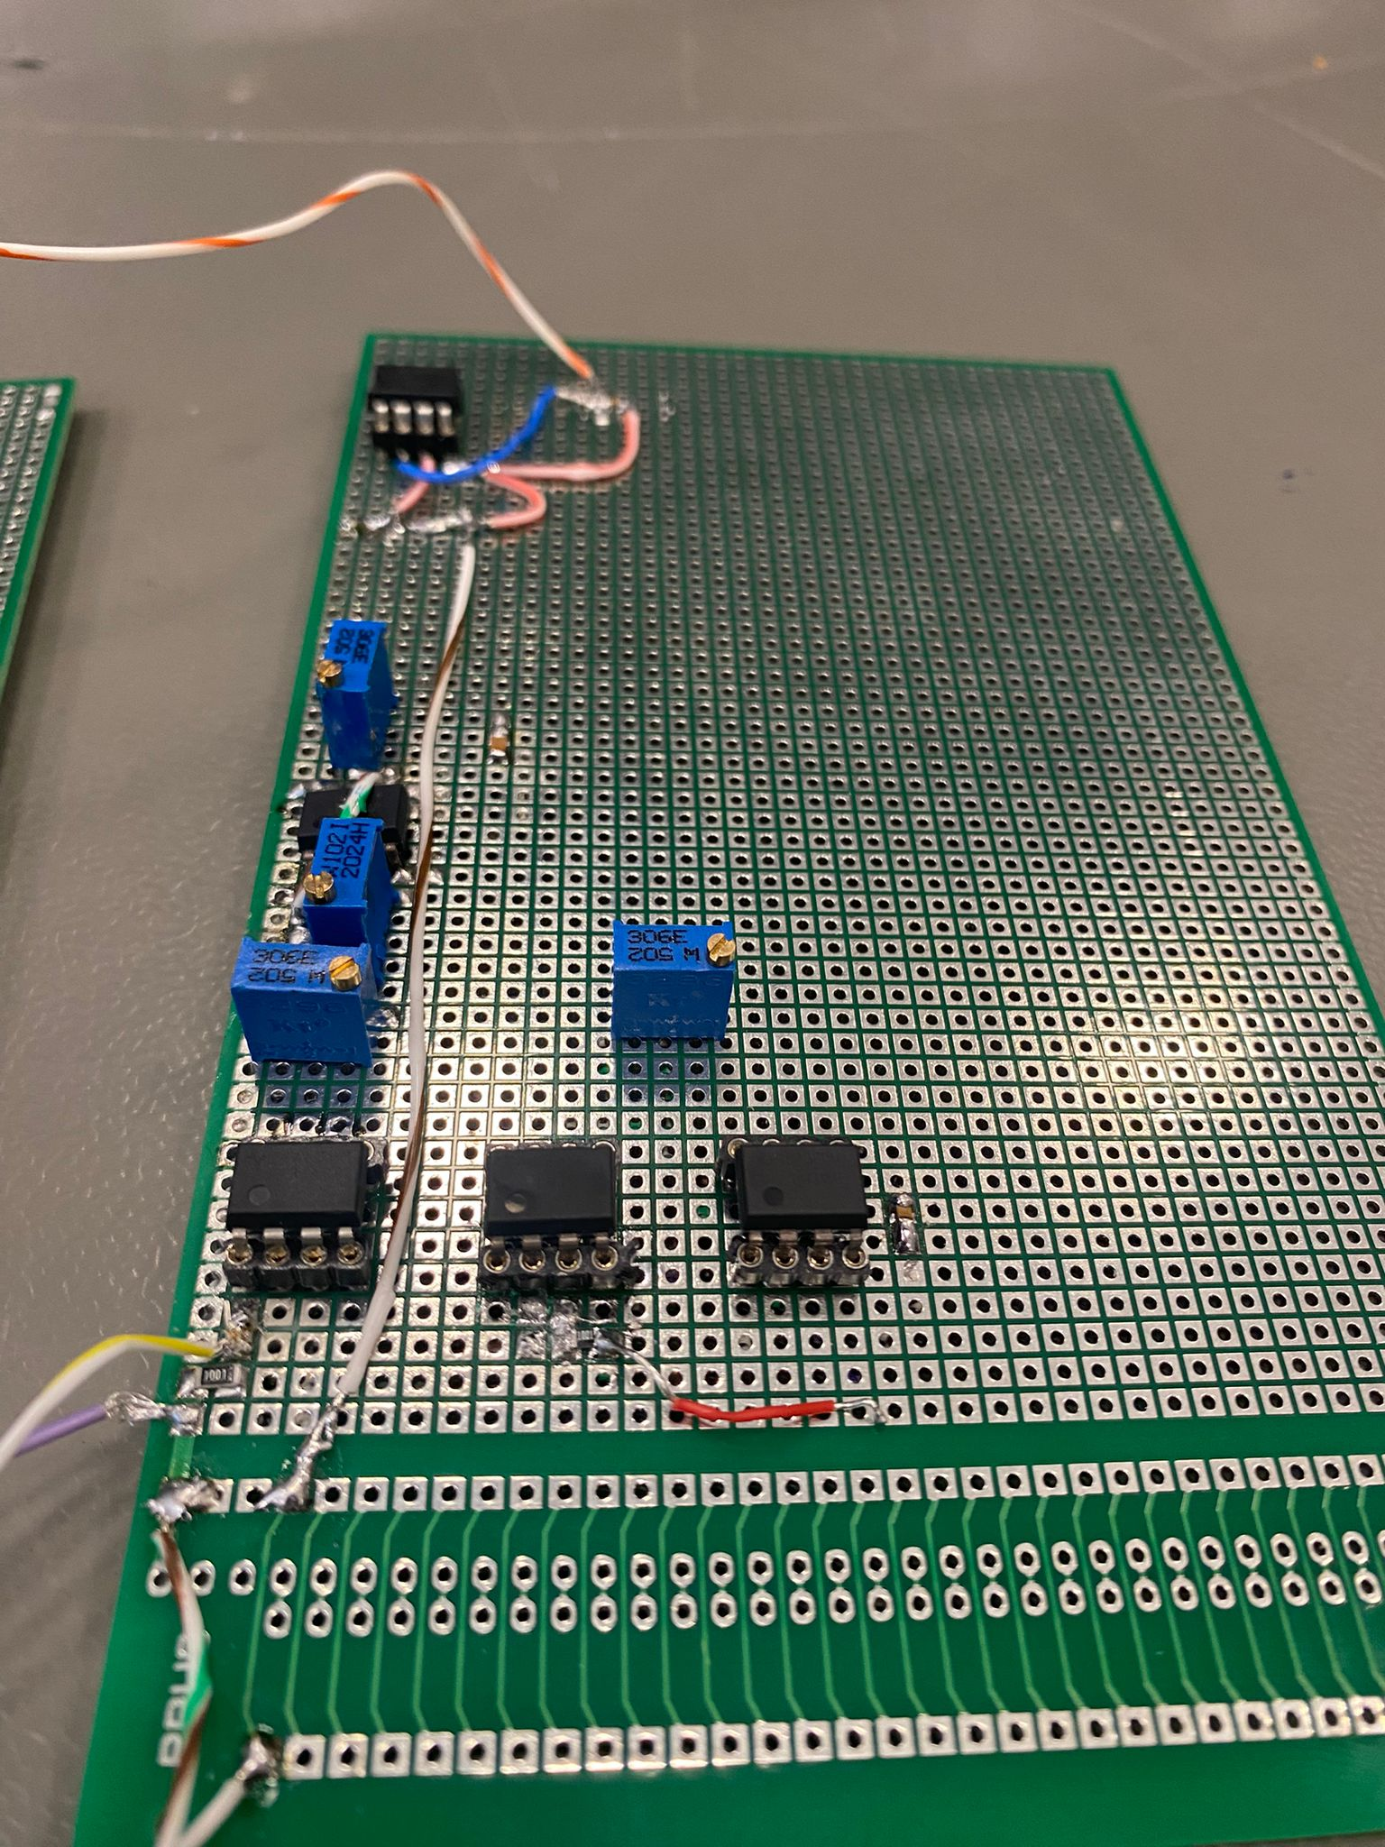

*Figure 15. Sawtooth signal (left) and comp_ref (right)*

After generating the necessary signals, we implemented the whole circuit. Since mostly SMD components and a perforated pertinax board is used, it took a long time to solder everything by hand. At the end of 2 weeks of soldering and trying different designs, the circuit was finally completed. The complete circuit can be seen in Figure 16.

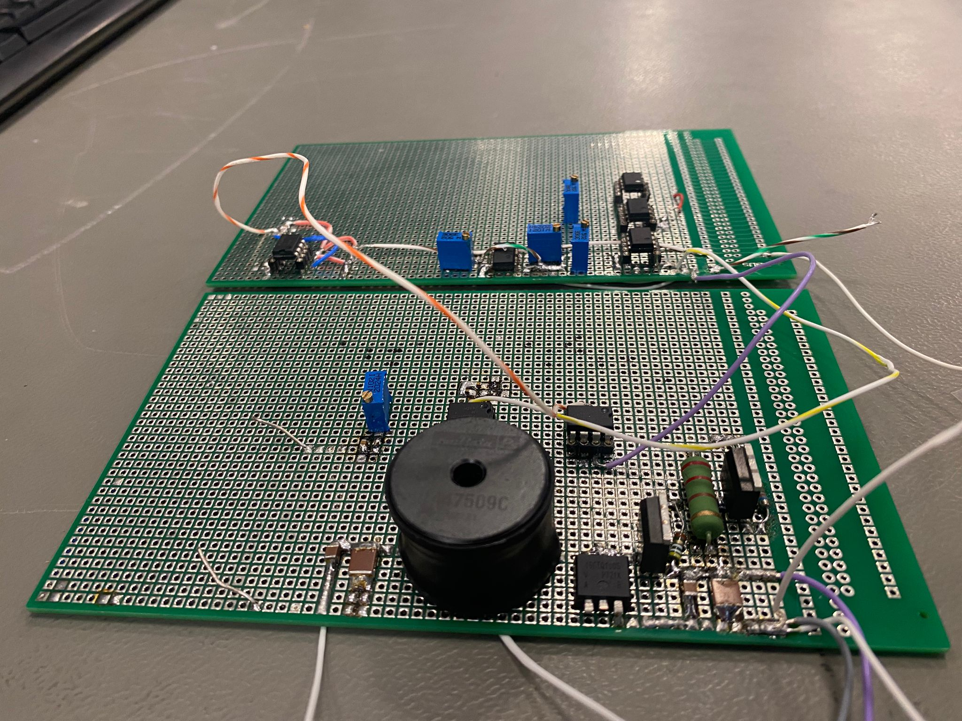

*Figure 16. Complete circuit*

**4.2 Measurements**

Figure 17. shows the output voltage level and output voltage ripple. The output voltage is 12V and the output voltage ripple is 8.6 mV, which is way below the maximum ripple given as %3.

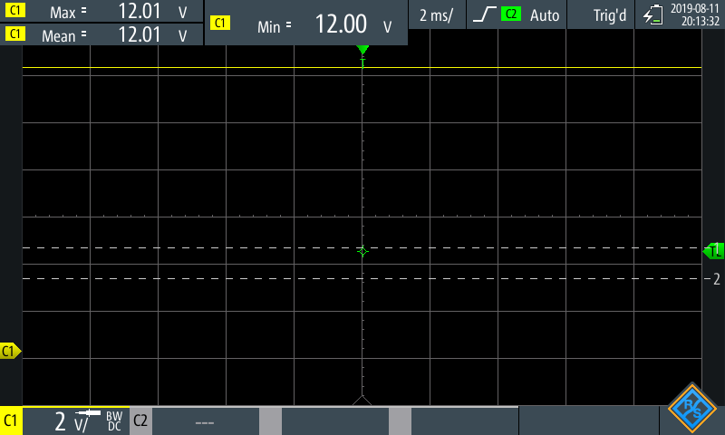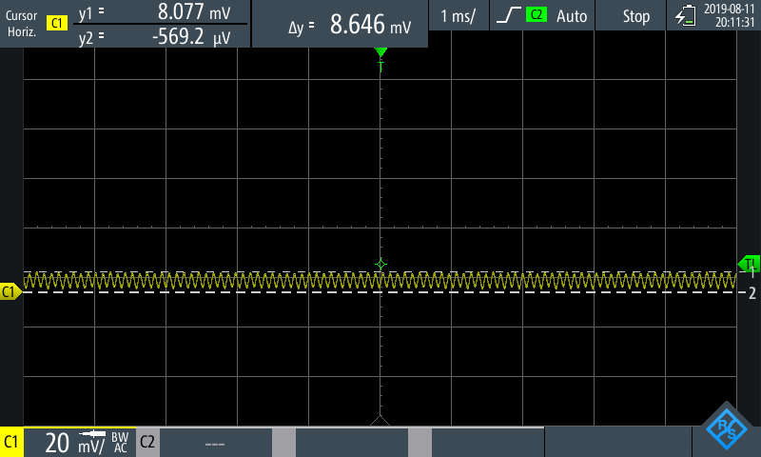

*Figure 17. Output voltage*

Figure 18 (although originally recorded for transient response) shows us the inductor current ripple as 176 mA, which corresponds to %43 ripple. This is slightly above the necessary value, due to the facts that the components are non-ideal and the frequency of the actual circuit is ever so slightly smaller than the design goal of 10 kHz. Another cause of this is as current goes through the inductor, inductor starts to become saturated, and reaches to a lower inductance value compared to the nominal value.

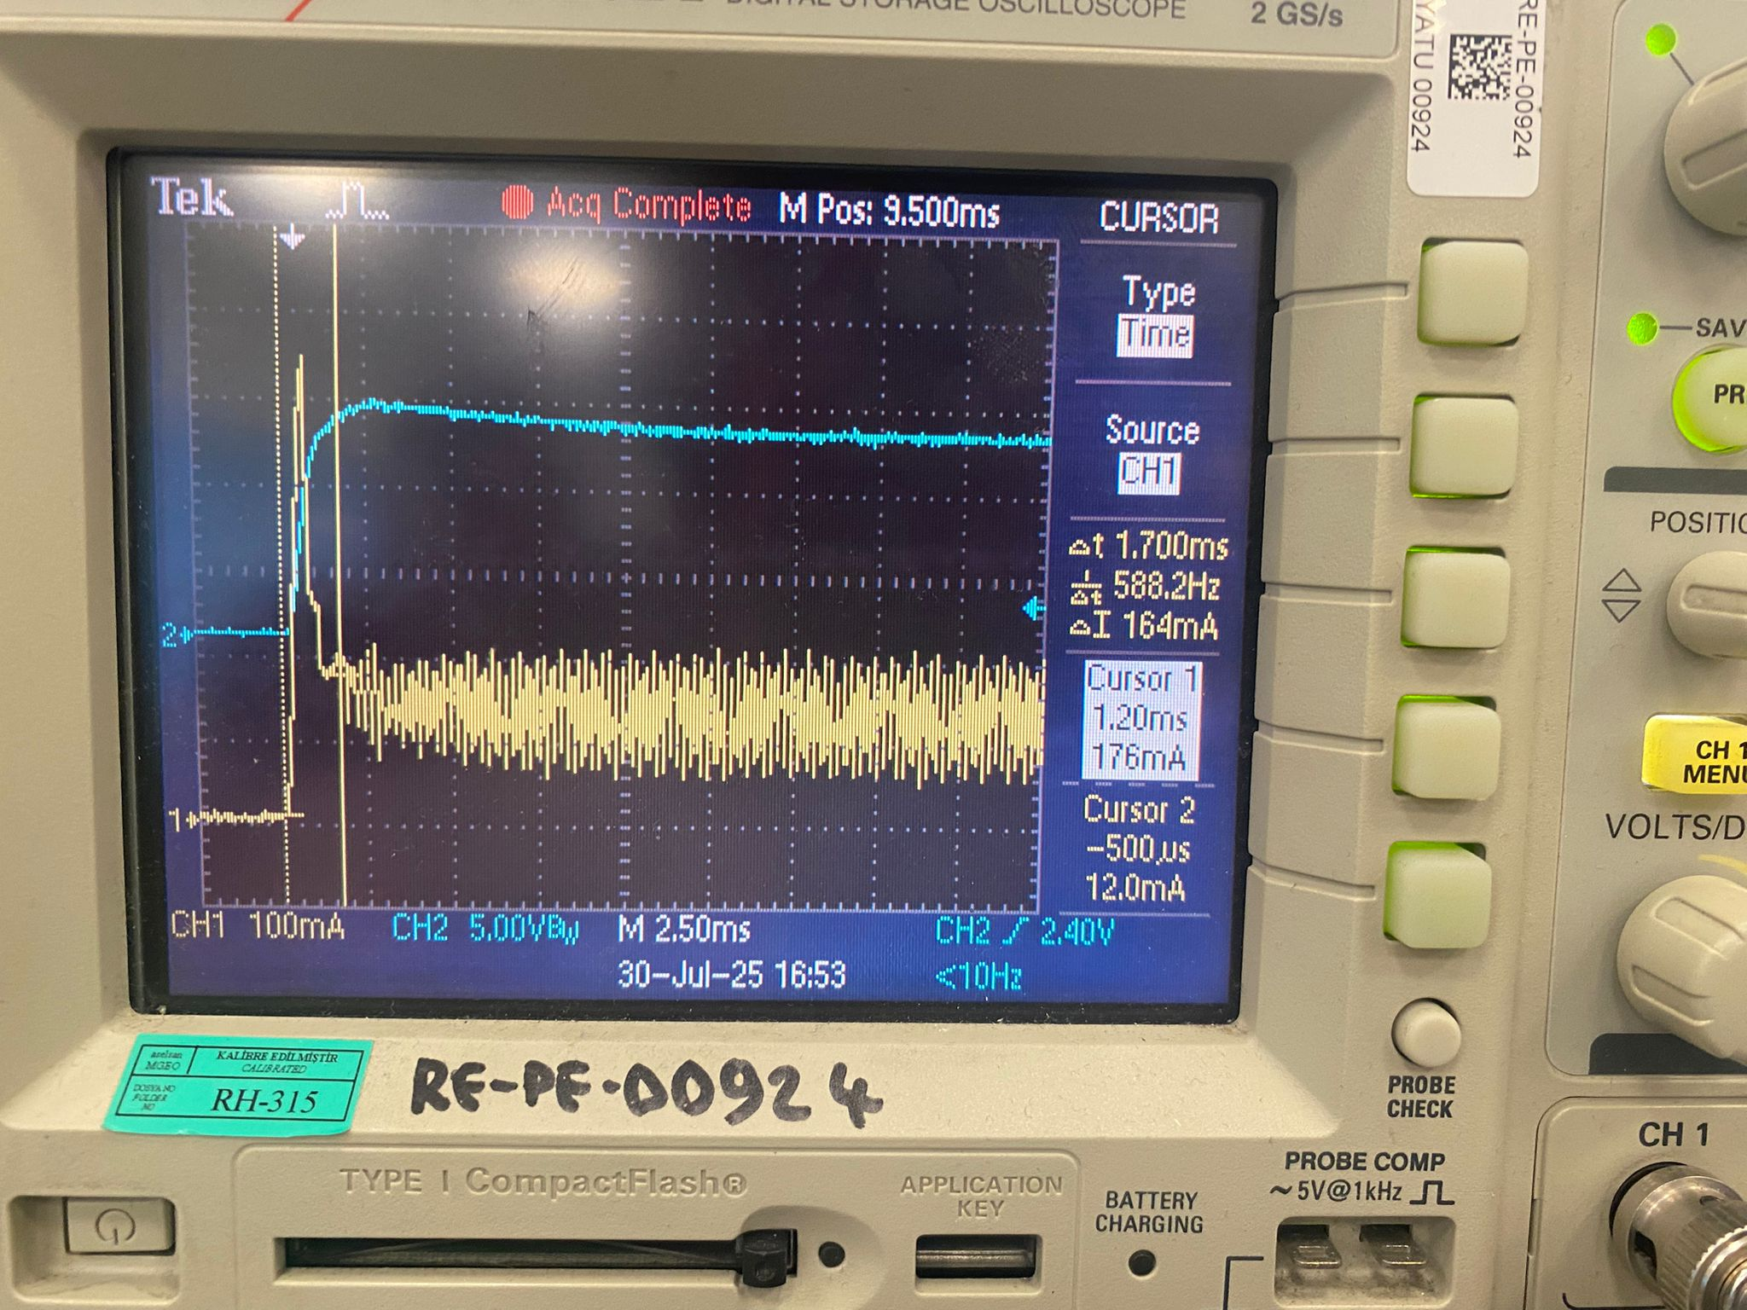

$$V_{out}$$

$$I_{L}$$

*Figure 18. Inductor current ripple*

Figure 19 shows the startup of the entire circuit, showing a 1V overshoot (remarked as acceptable by our mentor) and a settling time of between 2-3 ms.

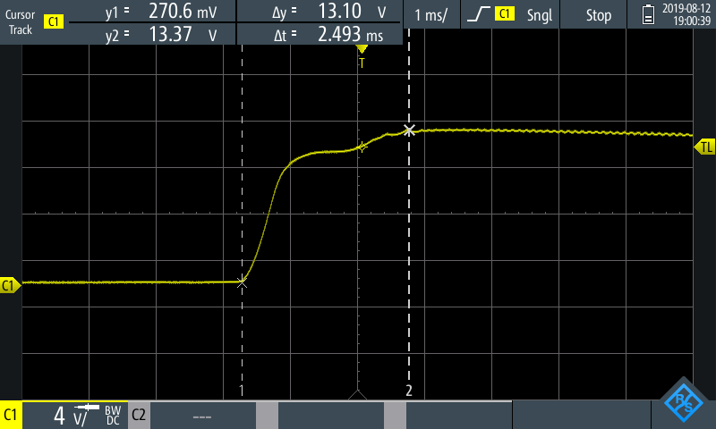

*Figure 19. Circuit startup*

Figure 20 shows the inputs of the comparator (same as the simulation in Figure 14) compared to each other. The PWM is generated when the error is bigger than the triangle wave. This is because the error goes into the non-inverting input and the sawtooth/triangle wave goes into the inverting input.

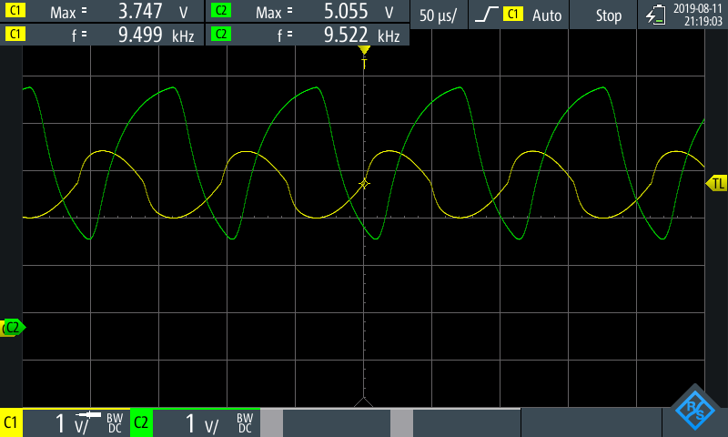

Triangle wave

Amplified Error

*Figure 20. Comparator Inputs*

In Figure 21, we can see the PWM compared to the triangle wave. We cannot see all three in one picture since the oscilloscope used during the measurement only supported two channels.

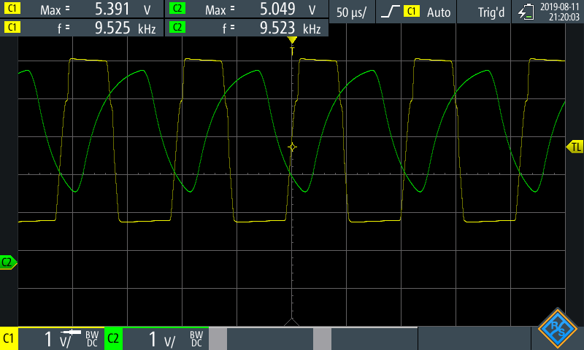

*Figure 21. Gate driver PWM and triangle wave*

In Figure 22, we can see the load and line regulations. The input limits were tested between 24-32V and the load was tested between 10% and 100% load. The limit was given as %3 by our mentor, but it can clearly be seen that it is much less than %3.

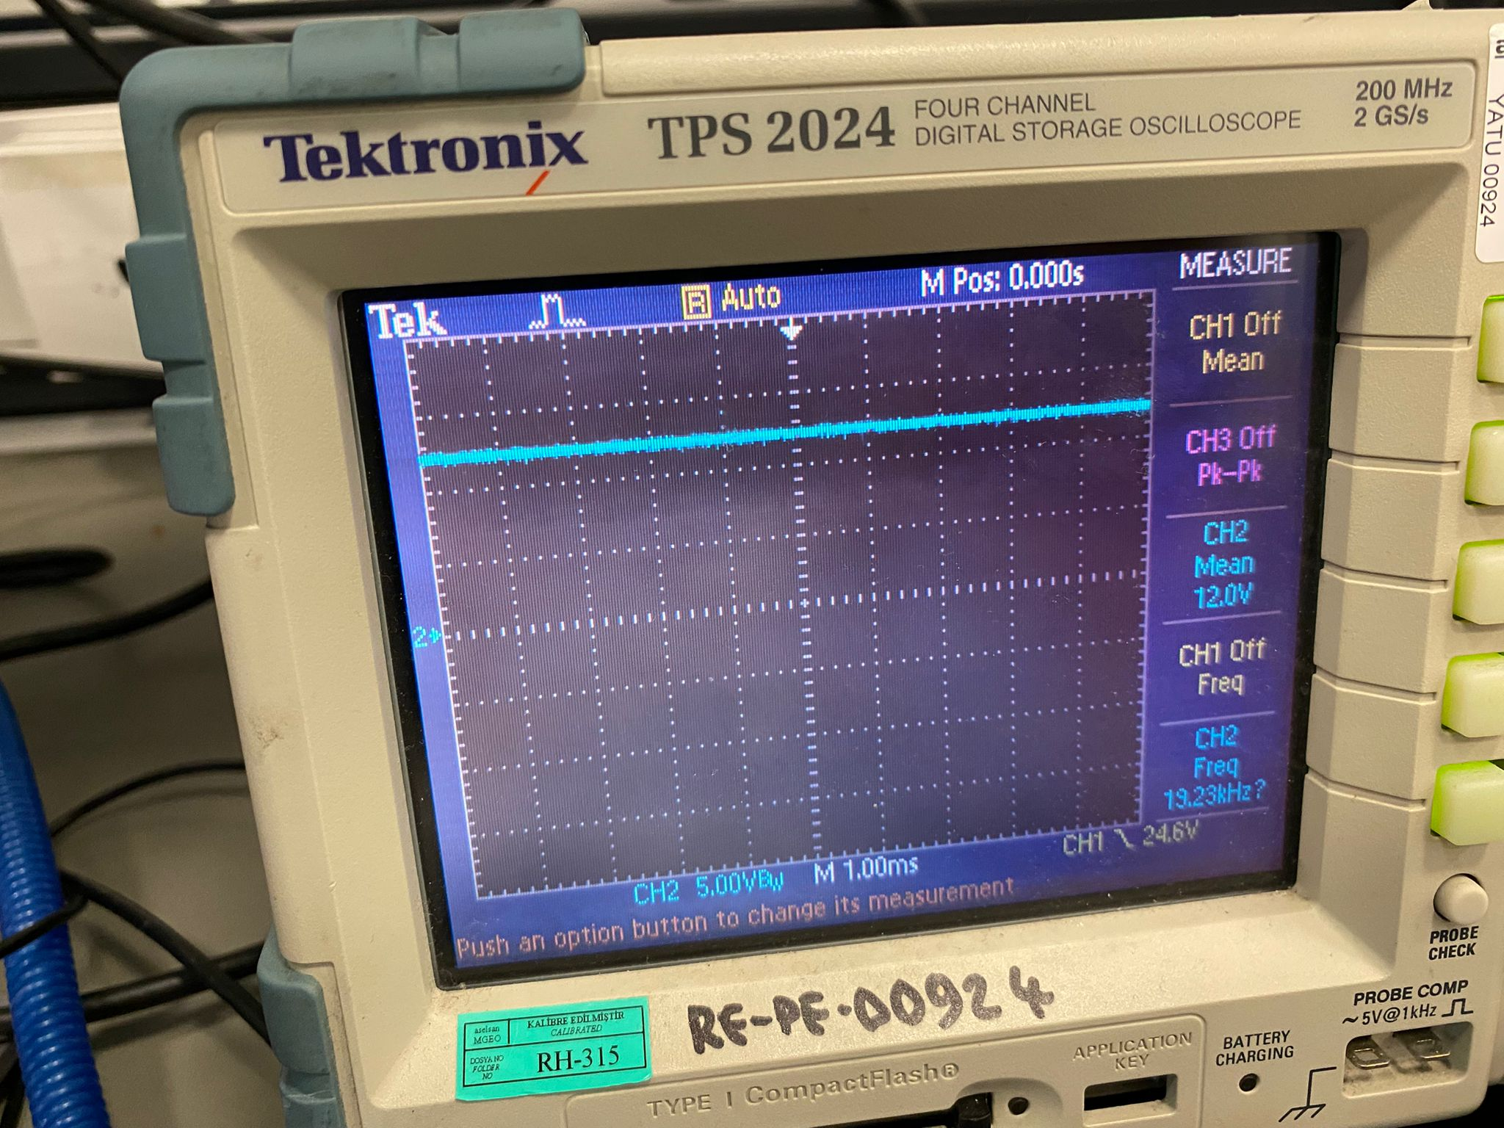 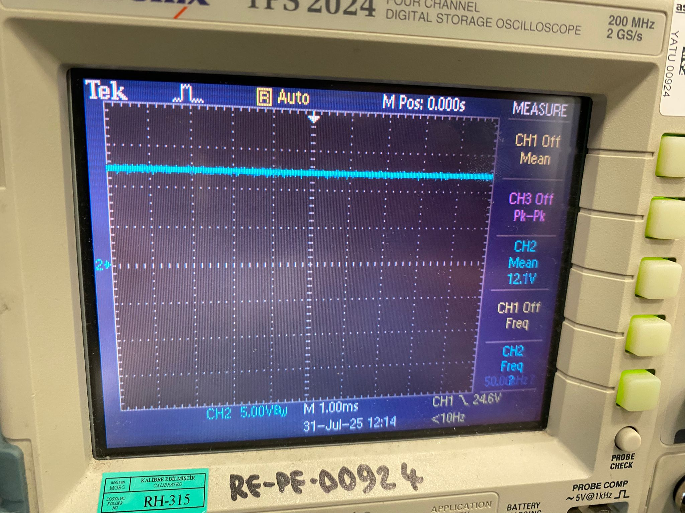

*Figure 22. Line and Load regulations*

In Figure 23, the load transient response can be seen. Load transient means that, when the circuit is working there is a sudden change in the load demands. This is a crucial measure of the feedback system, and it shows how well the system works. In this project, we could only measure the load transient but not the line transient as the necessary equipment was not available to us. We tested the load transient by suddenly changing the load current from %100 (400mA) to %10 (40mA). The output voltage had a jump of 1.2V, which is exactly our uppermost limit for a transient response of %10. This shows that the feedback system works as designed.

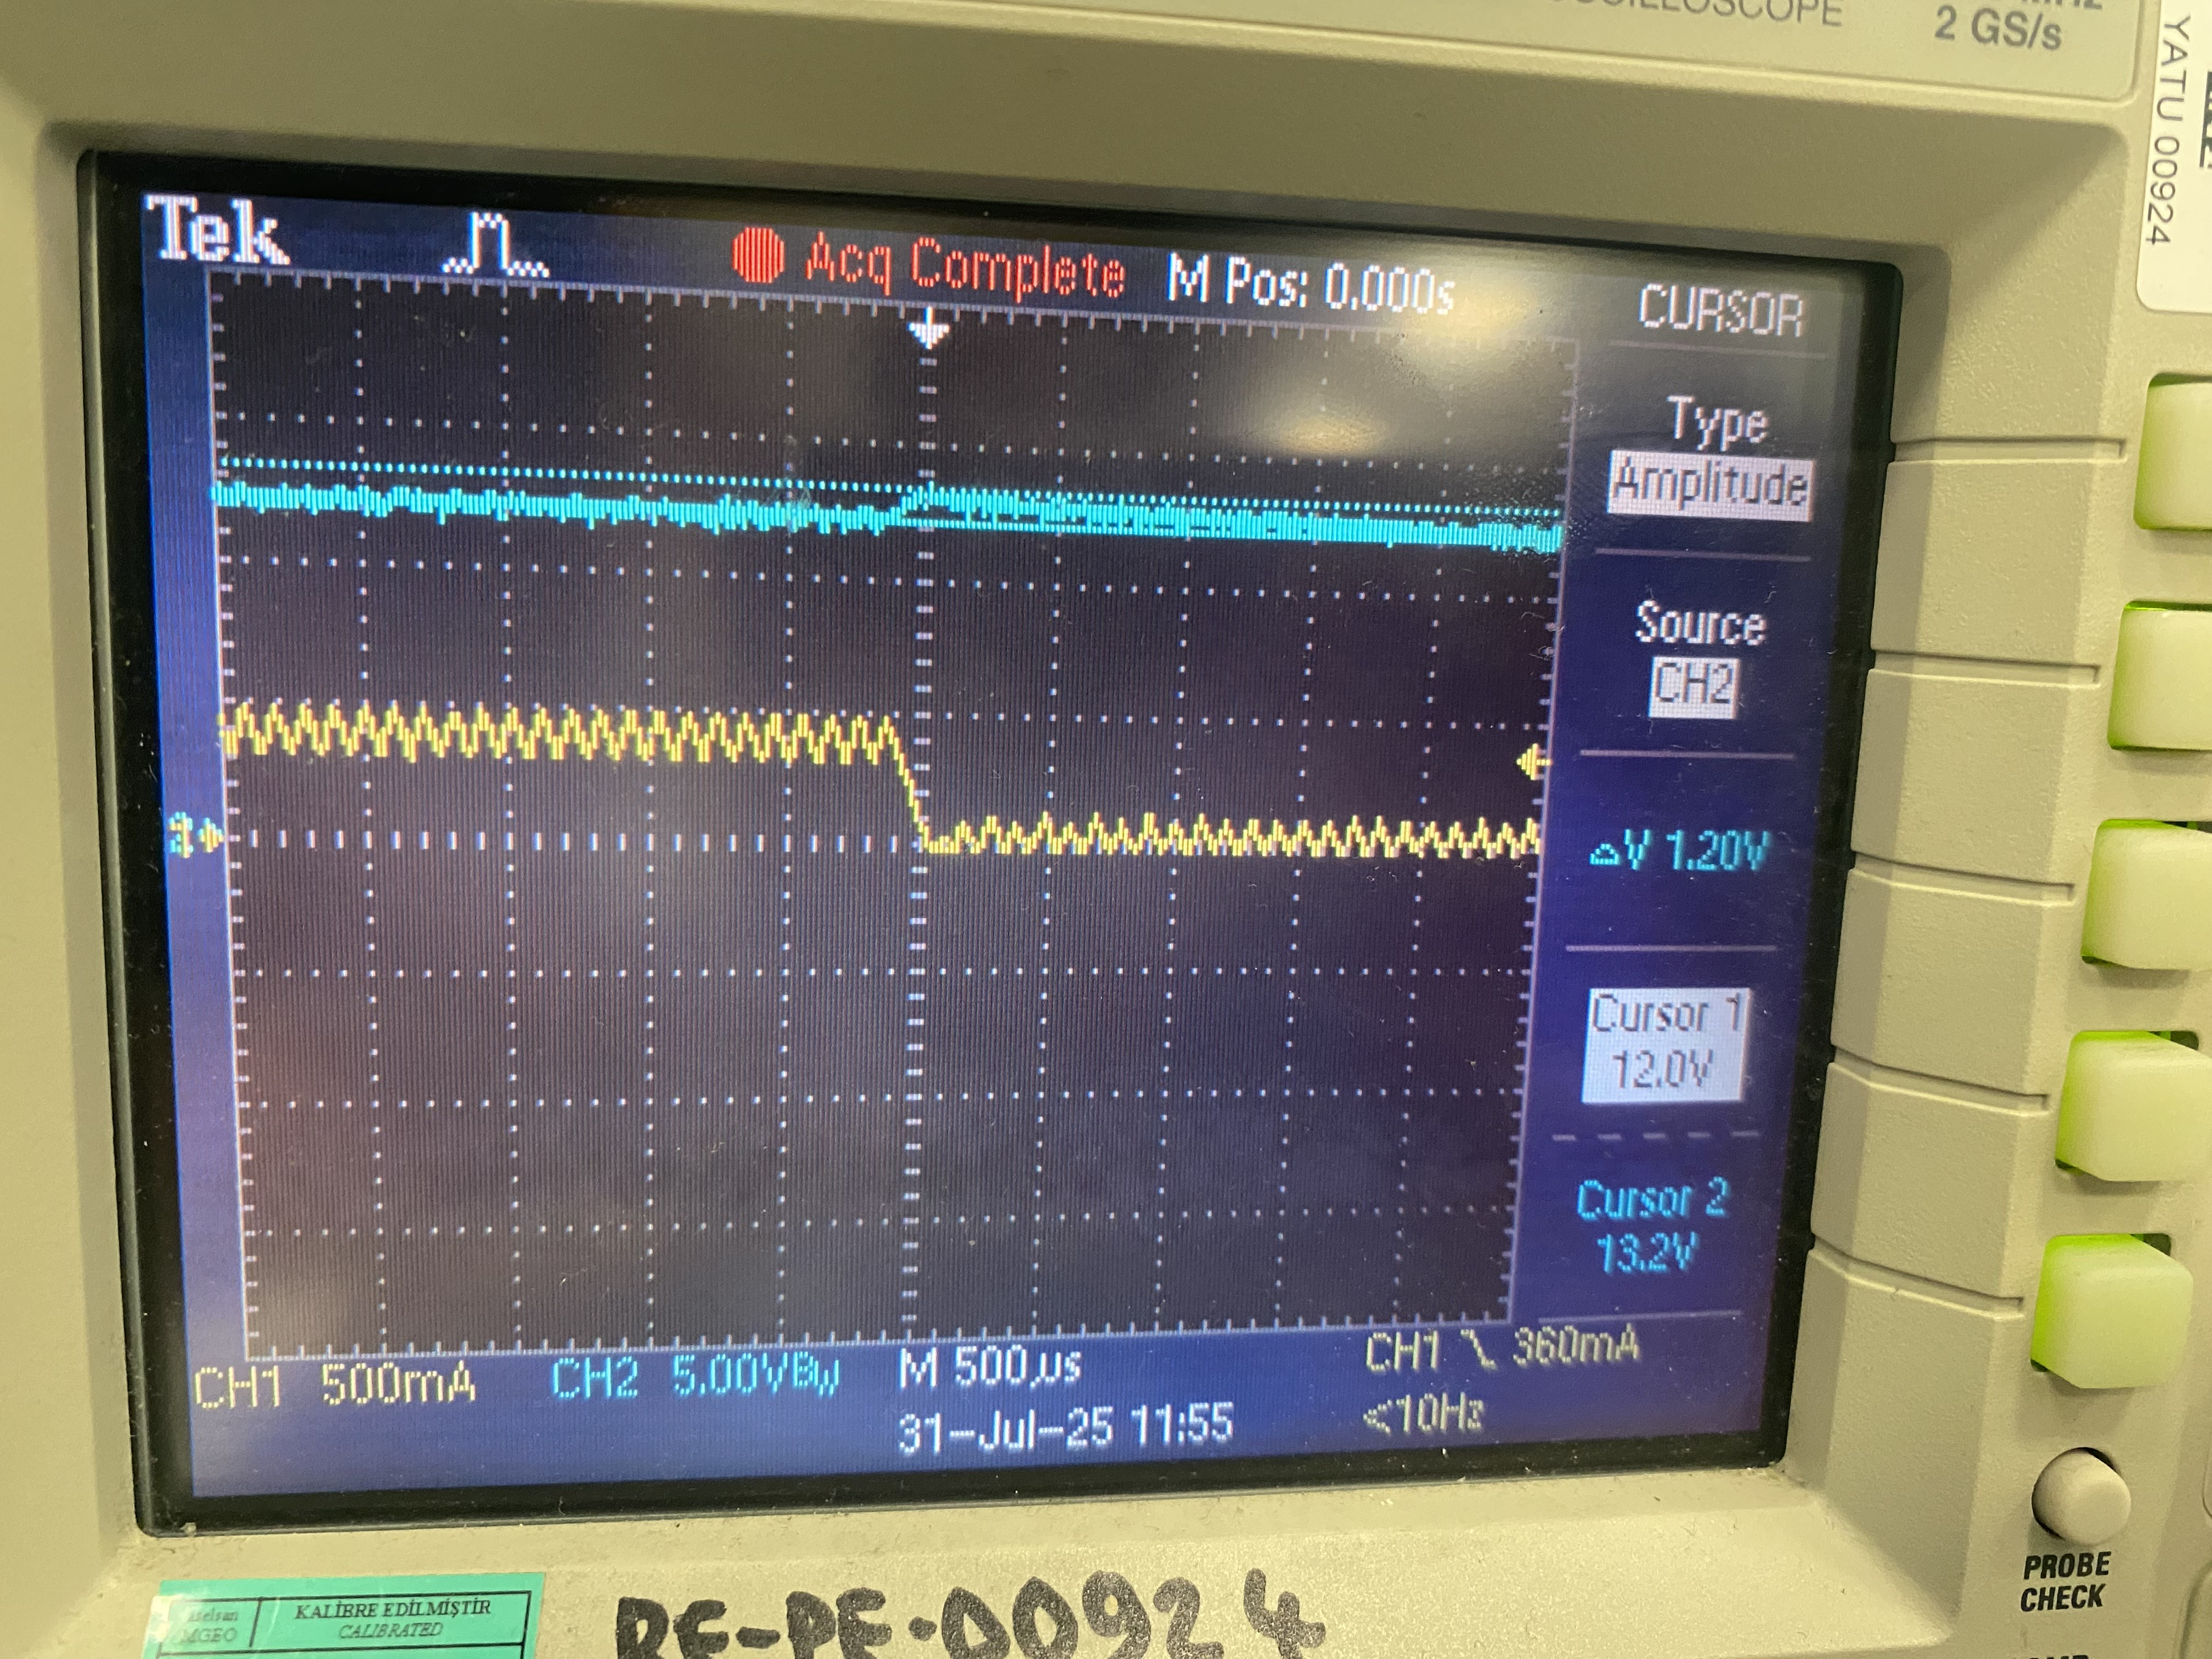

$$I_{L}$$

$$V_{out}$$

*Figure 23. Load transient response*

After all the measurements were taken, we wanted to see if a Type III compensator, or more specifically the feedforward capacitor was indeed necessary. To test this, we simply removed the feedforward capacitor and taken some of the measurements again. In Figure 24, the output voltage without the feedforward capacitor can be seen. Obviously, the “DC” output voltage is not very stable without the feedforward capacitor. This shows us that without a Type III compensator, we cannot have enough phase boost to reach to sufficient levels of phase margin, thus we end up with an unstable system that has oscillations.

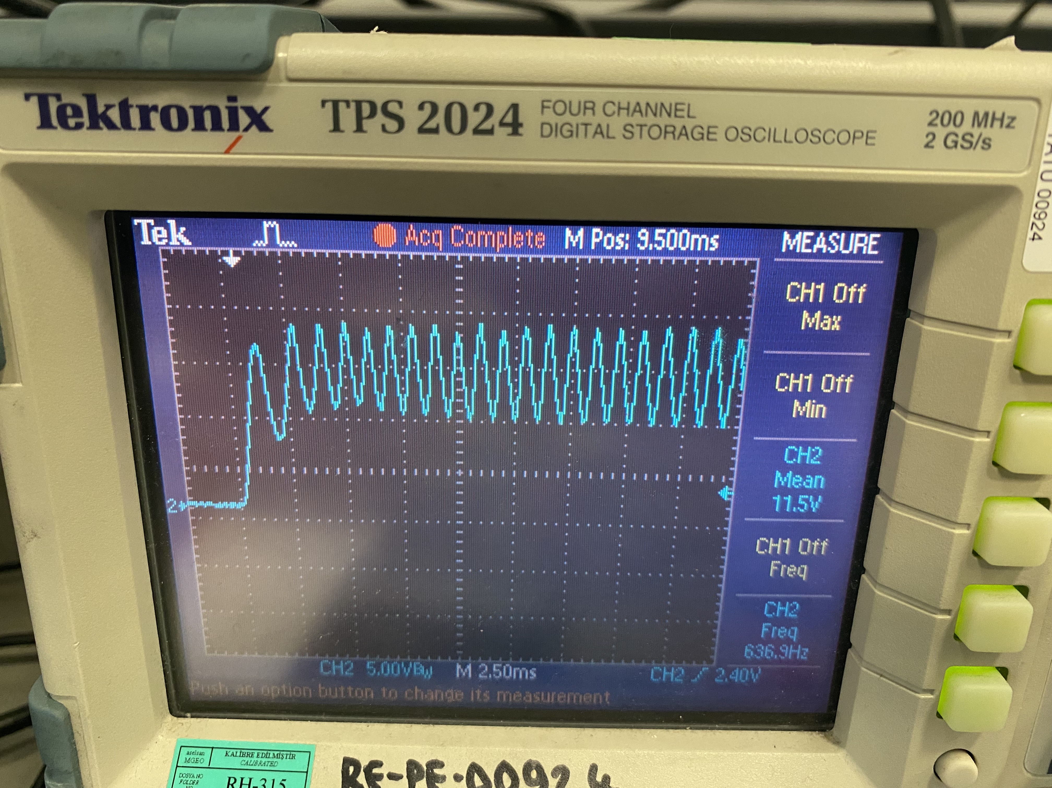

*Figure 24. Output without feedforward capacitor.*

In Figure 25, we can see the generated PWM and the amplified error signal once again. As can be clearly seen, the PWM is in very poor condition, having a lot of spikes and oscillations. One thing to note of in Figure 25 is that during the measurement, CH1 was inverted, and we did not have time to take the measurement once again at the time of noticing the mistake. Actual waveforms that we are supposed to see are given as a simulation in Figure 25 as well.

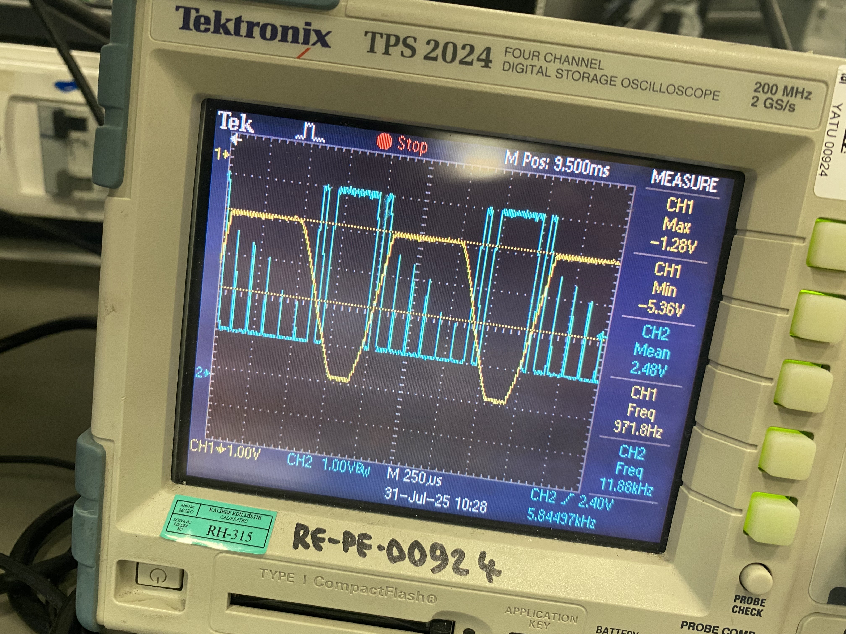 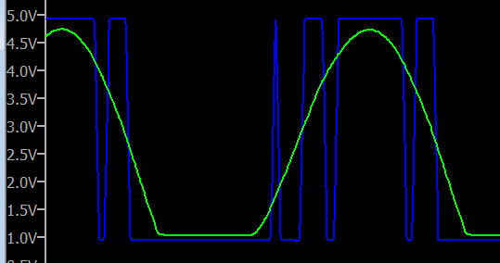

*Figure 25. Amplified error signal and gate driver PWM without feedforward capacitor*

**5 Conclusion**

To summarize our work during this summer internship, we have gained a much deeper understanding of SMPS systems. First, we researched the components, learning which types to use in our project by carefully considering crucial parameters. Then, taking a buck converter as the basis of our study, we learned about basic design methods and parameter selection. Next, we delved into control theory, studying various control methods for SMPS converters as well as different compensator types.

After completing the theoretical research, we designed and successfully implemented the feedback system for our buck converter. Finally, we built the circuit using real components and verified that it worked as intended. This project required considerable time and effort, but it greatly improved our understanding of SMPS design. With this experience, we can now more easily expand our knowledge to other types of converters. As a natural next step, we aim to further develop our expertise by studying control theory in greater depth and exploring isolated topologies, as planned by our mentor.

Another important outcome of this internship was the development of non-technical skills. Thanks to our mentor and other team members, we gained valuable insight into working in a professional environment. They taught us not only technical knowledge but also essential soft skills, helping us grow into well-rounded engineers. Working on this project with my fellow intern, Hüseyin Çetin (Gazi University, EEE, 4th year), made the process more efficient and further improved my teamwork abilities. I am grateful for this opportunity, and I feel one step closer to becoming a professional engineer.

**6 References**

**[1]** ASELSAN. (n.d.). About us. Retrieved August 13, 2025, from <https://www.aselsan.com/en/about-us>

**[2]** Wikipedia contributors. (2025, August 13). Buck converter. In Wikipedia. <https://en.wikipedia.org/wiki/Buck_converter>

**[3]** Erickson, R. W., & Maksimović, D. (2001). Fundamentals of power electronics (2nd ed.). Springer.

**[4]** Zhang, J., Wang, L., & Li, Y. (2021). Recent advances in DC–DC converters for renewable energy integration. Energies, 14(18), 5911. <https://www.mdpi.com/1996-1073/14/18/5911>

**[5]** Texas Instruments. (2008). Switch-mode power converter compensation made easy [PDF]. Retrieved from <https://e2e.ti.com/cfs-file/__key/communityserver-discussions-components-files/196/5706.COMPENSATION.pdf>

**[6]** Hart, D. W. (2011). Power electronics (1st ed.). McGraw-Hill.